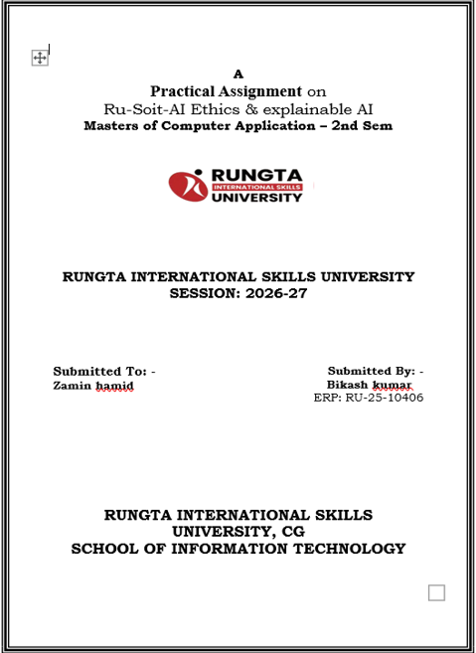
,,bb.f,bmd,mdmm
Project Report on Pesticide Spraying Optimiser
1. Title Page
Project Title: Pesticide Spraying Optimiser
Course: Master of Computer Applications (MCA)
Submitted By: Bikash Kumar
Session: [2026-2027]
College Name: [Rungta Skills University]
1. Introduction
Pesticide spraying is a critical agricultural activity aimed at protecting crops from pests and diseases. Traditional spraying methods often lead to excessive chemical usage, environmental pollution, and health hazards. This project proposes an AI-based Pesticide Spraying Optimizer that ensures efficient, targeted, and eco-friendly spraying.
2. Objectives
- To minimise pesticide wastage by optimising spray coverage.
- To reduce harmful environmental impact.
- To integrate sensors and AI algorithms for precision spraying.
- To improve crop yield and farmer safety.
3. Literature Review
- Conventional Spraying: Manual sprayers often result in uneven distribution.
- Drone-based Spraying: Emerging technology but costly for small farmers.
- AI & IoT Integration: Recent studies show that machine learning can predict pest density and optimize spray accordingly.
4. Methodology
1
Data Collection
Gather crop and pest-related data for analysis.
- Use IoT sensors to detect pest density
- Collect soil and weather data
- Record pesticide usage history
2
AI Model Training
Develop machine learning models to predict optimal spray levels.
- Train models using collected datasets
- Apply regression and classification algorithms
- Validate accuracy with test data
3
Spray Optimization
Generate optimized spraying patterns based on AI predictions.
- Calculate required pesticide quantity
- Adjust nozzle pressure and spray angle
- Ensure uniform coverage
4
Implementation
Deploy optimizer in real-world agricultural fields.
- Integrate with drones or smart sprayers
- Monitor spraying efficiency
- Collect feedback for continuous improvement
5. Expected Outcomes
- Reduction in pesticide usage by up to 30%.
- Improved crop health and yield.
- Lower environmental contamination.
- Cost-effective solution for farmers.
6. Conclusion
The Pesticide Spraying Optimizer combines AI, IoT, and smart spraying mechanisms to revolutionize agriculture. By ensuring precision and sustainability, it supports both farmers and the environment.
7. References
- Research papers on AI in agriculture.
- IoT-based pest monitoring systems.
- Case studies on drone spraying technology.
📘 Project Report
Title: Pesticide Spraying Optimizer Course: Masters of Computer Application – 2nd Semester Institution: Rungta International Skills University Session: 2026–27

